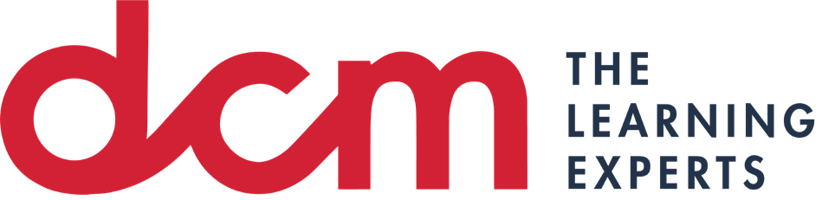

This material is copyright of DCM Learning. All rights reserved. You may not, except with our express written permission, distribute or commercially exploit the content. Nor may you transmit it or store it by any other means or other forms of an electronic retrieval system.

Assessment 2: Learner Record

**Task 1 (4 parts)**

Your learner record should be a self-reflective record in which you describe your learning experiences and insights during the course. The Learner Record should not be a summary of the course learning but should describe how you found the learning useful and how you will make use of what you have learned to improve in your people management role going forward. As you go through the course, we advise that you

use the Learner Record Log in your course workbook to keep a record of what you have learned during the course and how you think it will be useful.

The learner record should be written in the first person and should:

* Briefly describe what you have learned on the course
* Discuss how you found this learning useful or insightful
* Discuss, with specific examples, how you will use these insights to make you a more effective people manager

# Hershey and Blanchard Situational Leadership Style or Belbin Team Role

(15 marks, 375 words)

# Motivation theories (Maslow / Herzberg) or Delegation

(15 marks, 375 words)

# Communication skills: active listening, questioning skills, communication style

(15 marks, 375 words)

# Providing feedback: SAID feedback model, fundamentals of feedback

(15 marks, 375 words)

**Bibliography & References**